## Technical Assessment

**Name: ­­­­­­­­­­­­­ _______________Edima Udo_________________________**

Please note that the information contained in this document is private and confidential and should not be shared with others.

This test is divided into two sections. It is designed to test your technical and business knowledge. You are given **60 minutes** for this test.

1. Part I: Technical assessment
2. Part II: Pre-sales and Business Analysis

Please let us know if you have any questions. Good luck.

### **Technical**

**SQL**

1. The Employee table shows information about the employees in Dundas. Note that the **IDs in ManagerID are also EmployeeIDs**, For example, Jenik’s manager is Timothy.

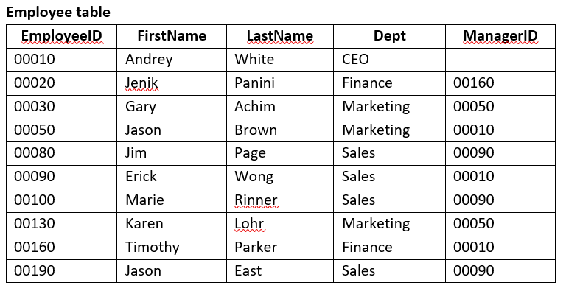

* 1. Write a query returning the full name of every employee containing the letter M in the first name, sorted by last name

Select e.FirstName + “ “ + e.LastName as FulName

From Employee e

Where Upper(Left(e.FirstName,1)) = “M”

Order by e.LastName ASC

* 1. Write a query returning the full names of employees that directly report to the CEO. (This query must continue to work if the CEO’s name or employee ID change.)

Select e.FirstName + ‘ ’ + LastName as EmployeeFullName

From Employee e

Where e.EmployeeID in (Select e2.EmployeeID from Employee e2 where e2.ManagerID = (select e1.EmployeeID from Employee e1 where e1.Dept = “CEO”))

* 1. What department has the largest number of employees?

Select e.Dept, Count(e.Dept)

From employees e

Group by e.Dept

Order by 2 DESC

Limit 1

1. Given the database tables below, find the following:

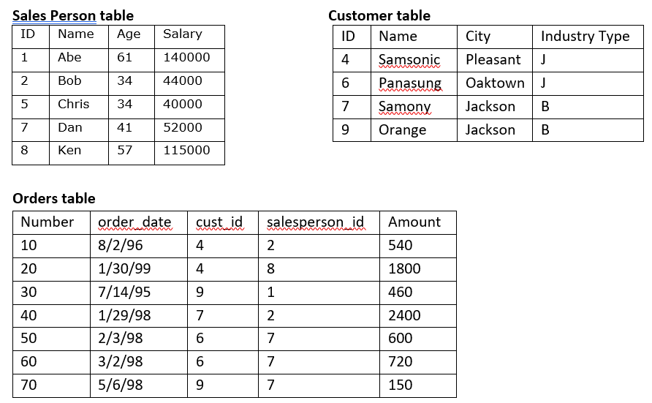

1. Write a query returning the names of sales people with no orders

Select S.Name

From SalesPerson S

Where S.ID in (O.salesperson_id from Orders group by O.salesperson_id having count(cust_id) < 1)

1. Who is the top sales person overall and what is their sales amount?

Select S.Name, Sum(Amount) as SalesAmount

From SalesPerson S, Orders O

Where S.ID = O.salesperson_id

Group by S.Name

Order by 2 ASC

Limit 1;

**C# and .NET**

1. Please read through the code below and explain what the code is doing

public static bool MethodToIdentify**(**string a**,** string b**)**

**{**

char**[]** char1 **=** a**.**ToLower**().**ToCharArray**();**

char**[]** char2 **=** b**.**ToLower**().**ToCharArray**();**

Array**.**Sort**(**char1**);**

Array**.**Sort**(**char2**);**

string aWord **=** new string**(**char1**);**

string bWord **=** new string**(**char2**);**

if **(**aWord **==** bWord**)** **{**

return true**;**

**}**

else **{**

return false**;**

**}**

**}**

**It is checking if two words are the same. It looks similar to an anagram.**

1. Given the base class below, provide a class definition that inherits for the base class.

public class **<**base_class**>** **{**

**...**

**}**

1. What is the value of “z” after the following code runs?

x = { “foo”: “bar” }

y = { “baz”: x }

z = y[“baz”][“foo”]

Select the correct answer:

1. “foo”
2. “baz”
3. Runtime error
4. “bar”
5. “x”

Explain your answer:

d) Bar

y(baz) produced x

and when x is called it looks up foo key which generates bar

1. Write a method to calculate the factorial of a number. Eg: 5! = 120. Hint: Use recursion.

*\*\*It’s okay to write pseudo code if you are not sure about the exact syntax*

public static long Factorial**(**long number**)**

**{**

If (number == 1)

return 1;

else

return number * factorial(number – 1);

**}**

**HTML, JavaScript and jQuery**

1. Write code to have the “button” open a new tab and navigate to [www.dundas.com](http://www.dundas.com)

<button type="button">

<a href="https://www.dundas.com"></a>

</button>

1. Write code to set the color of the label text to red and the font size to 20

<label id="lbltip">test</label>

<script>

var info = document.getElementById('lbltip');

info.style.color = "red";

info.style.font = 20;

</script>

1. Write a piece of script that will find the smallest value in a string. For example in the string

var s **=** '5, -12, 3, 8, -5, 0', -12 is the smallest value.

*\*\*It’s okay to write pseudo code if you are not sure about the exact syntax*

function findSmallest**(**s**)**

**{**

**var s_data = s.split(“,”);**

**sdata.sort;**

**return s[0];**

**}**

1. Convert the following table into a JSON array called employee. What would the output look like?

**Employees**

|  |  |  |
| --- | --- | --- |
| **firstName** | **lastName** | **salesRegion** |
| John | Doe | Toronto |
| Anna | Smith | Hamilton |
| Peter | Jones | Markham |

Employees = [

{

"FirstName": "John",

"LastName": "Doe",

"Region": "Toronto"

},

{

"FirstName": "Anna",

"LastName": "Smith",

"Region": "Hamilton"

},

{

"FirstName": "Peter",

"LastName": "Jones",

"Region": "Markham"

}

]

### Pre-sales and Business Analysis

1. You are asked to do a presentation to a prospect. What questions would you ask before you go into the presentation?

Who is the client?

What is the prospects business area?

Where is the client located?

What is the clients pain point?

How is our solution going to help the client meet their need?

Where in the BI life-cycle is the client in?

1. Now imagine you are hired as a business analyst.
   1. In an organization of disparate data sources, what would you do to deliver a successful dashboard initiative? If you need to make any assumptions, please state them. Make sure to explain why you would take each action in your plan.

Successful delivery of a dashboard initiative is driven by great collaboration between all the stakeholders involved in the design. The ultimate goal of the dashboard is for the end user to make timely and smart decisions in order to improve current business performance. The following steps are key to successful delivery.

1) **Requirements gathering**:

This involves meeting with the client to understand the problem for which the dashboard is being created for. It also involves getting all the stakeholders (end users, IT team, project manager, Business analyst) together and making sure they are onboard with the initiative. After this the business requirements can be collected. This involves the reviewing business data, metrics to be measured, understanding the current process and outlined the end goal of dashboard.

The requirements gathering is important because it is the foundation for solving the business problem.

2) **Understanding the clients data**

This involves understanding the type of raw data that would be used, the database infrastructure of the client, how the data would be consumed (real time or over a certain period of time). Collaborating with the IT/database team would be helpful at this stage. This stage is important as it gives the designers a better understanding of the current technologies and the data.

3) **Dashboard design**

The dashboard design involves how to pair the clients data in the way that it would make the most sense and ensure the best user experience in terms of data visualization and user interface design.

In this stage it could involve producing multiple prototypes of the dashboard and getting potential users to provide feedback on the design. This stage is important because it brings to life the business requirements and the actual design. It also makes sure the design is in line with the business requirements and ensures the end user is involved in the design.

4) **Delivery**

Delivery comprises of

* Finishing the dashboard design
* Testing the implementation
* Creating documentation (user manual, troubleshooting guide)
* Designing a maintenance road map for the end user (customer support)
* Deploying the dashboard to end user

Delivery is the final stage of dashboard initiative as it showcases the designed dashboard and when deployed it would solve the business problem.

* 1. How would you design the following dashboard with these requirements? A sketch on a piece of paper is acceptable, but be sure to be clear on what you are showing (it’s open for interpretation for a reason, so do your best).

Metrics with sample data:

Sales by Month

|  |  |
| --- | --- |
| SalesMonth | Sales |
| Dec. 1, 2008 | $100,000.00 |
| Jan. 1, 2009 | $150,000.00 |
| Feb. 1, 2009 | $180,000.00 |

Target Sales by Month

|  |  |
| --- | --- |
| SalesMonth | Sales Target |
| Dec. 1, 2008 | $90,000.00 |
| Jan. 1, 2009 | $170,000.00 |
| Feb. 1, 2009 | $150,000.00 |

Rep Sales Performance

|  |  |
| --- | --- |
| Rep | Revenue |
| John | $30,000.00 |
| Harry | $50,000.00 |
| Anna | $90,000.00 |

Sales by US region (NorthEast, NorthWest, SouthEast, SouthWest)

|  |  |
| --- | --- |
| Region | Revenue |
| NorthEast | $130,000.00 |
| NorthWest | $190,000.00 |
| SouthEast | $220,000.00 |
| SouthWest | $320,000.00 |

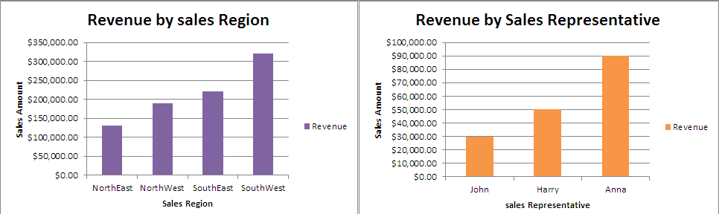

1. What other metrics do you think would be relevant with this dashboard?

Sales by US region by month

Rep sales by month

Rep target sales by month

Rep sales by region